**Lesson08 html attribute and DOM Property**

**Notes:-**

**\*What is DOM:-**  
**DOM stands for Document Object Model. When a browser loads a web page, the browser creates a Document Object Model of that page.**

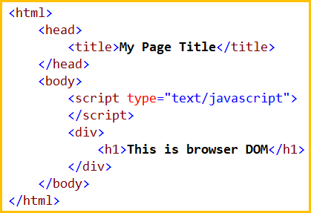

The browser creates a Document Object Model of that page as shown below

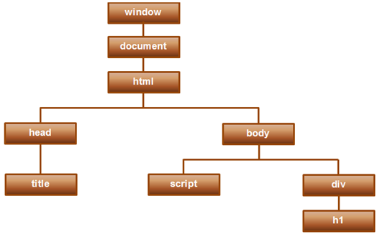

**1-DOM as an application programming interface (API) for HTML, and we can use programming languages like JavaScript, or JavaScript frameworks like Angular to access and manipulate the HTML using their corresponding DOM objects.**

**2-In other words DOM contains the HTML elements as objects, their properties, methods and events and it is a standard for accessing, modifying, adding or deleting HTML elements.**

**In the previous 2 videos we discussed interpolation and property binding in Angular.  
  
Interpolation example  
<button disabled='{{isDisabled}}'>Click Me</button>  
  
Property binding example  
<button [disabled]='isDisabled'>Click Me</button>**

**We have to know that we apply the disabled property on the button object**

**What is the difference between HTML element attribute and DOM PROPERTY?**

**1-Attributes are defined by HTML, whereas properties are defined by the DOM.**

**2-Attributes initialize DOM properties. Once the initialization complete, the attributes job is done.**

**3-Property values can change, whereas attribute values can't.**

**Example**

**1-we will put the element text and set value=’Tom’**

**<input id='inputId' type='text' value='Tom'>**

**2-on the Developer Tools we will set the attribute on the console option and set the command**

**inputId.getAttribute('value');**

**3-even of you change the value of the text, the attribute won’t change**

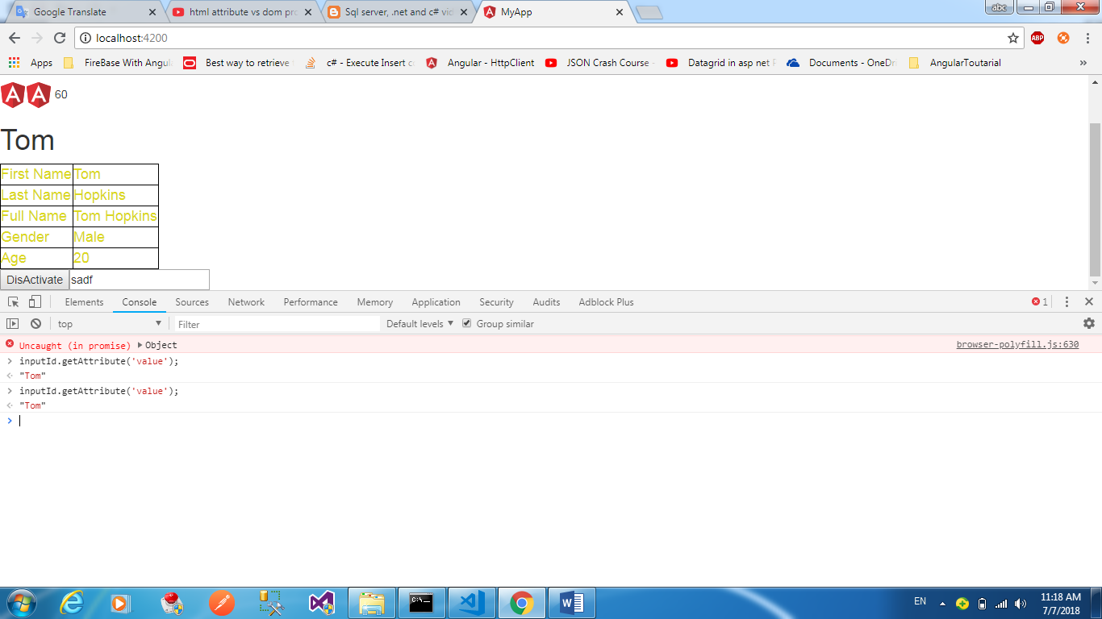

**1-HTML attributes and the DOM properties are different things.**

**2-Angular binding works with properties and events, and not attributes.**

**3-The role of attributes is to initialize element properties and their job is done.**